Infosys Springboard Virtual Internship 6.0 Completion Report

Team Details

Batch Number: 01
Start data: 22-NOV-2025
Names:

S.No. | NAME
1 | Keerthana Sanivada
2 | Thanuja Vanjarapu
3 | Sri Anjhanee Kunchanapalli
4 | Hemanthraj D
5 | Deepak P

Internship Duration: 8 Weeks

1) Project Title

SMART HOME ENERGY MANAGEMENT SYSTEM (SHEMS)

2) Project Objective (SREMS)
The Smart Residential Apartment Energy Management System (SREMS) is a web-based application designed to monitor, manage, and optimize electricity usage across a residential apartment community. With the growing need for energy efficiency, cost reduction, and sustainable living, SREMS provides an intelligent platform that enables both residents and apartment management to track energy consumption at the flat level as well as in shared common areas such as corridors, gyms, parking spaces, and community halls.
The system aims to bridge the gap between traditional apartment electricity monitoring methods and modern smart residential requirements. Instead of relying only on monthly billing and manual supervision, SREMS offers real-time energy insights, role-based device management, automated scheduling, alerts, and analytical dashboards that support informed decision-making and efficient energy utilization. The application is developed using Java Spring Boot, follows a secure layered architecture, and supports scalable module-based expansion to meet future smart community needs.

3) Project Description (SREMS)
Modern residential apartment communities consume a significant amount of electricity due to the continuous operation of appliances inside individual flats as well as shared facilities such as corridor lighting, elevators, water pumps, gyms, parking areas, and community halls. In many cases, these energy resources are not monitored effectively, leading to unnecessary wastage, high electricity bills, and inefficient manual control.
Existing apartment energy management approaches mainly depend on monthly electricity billing and lack real-time visibility into appliance-level consumption. Residents and management committees often do not have a centralized platform to track usage patterns, detect abnormal consumption, or enforce energy-saving practices across the community.
To address these challenges, the Smart Residential Apartment Energy Management System (SREMS) provides a centralized and intelligent solution that enables secure role-based access for different stakeholders such as Admin, Secretary, Security Staff, Flat Owners, Residents, and Guests. The system supports smart device management, real-time monitoring, alerts for high usage or faults, analytical reports, and automation through scheduling rules.
Developed using Java Spring Boot with a layered architecture and MySQL database integration, SREMS ensures scalability, security, and efficient energy optimization, making it suitable for smart residential societies and sustainable community living.
4) Timeline Overview

Week | Activities Planned | Activities Completed
Week-1 | During the first week, the project was introduced and the overall problem statement was discussed. The team finalized the project scope, expected outcomes, and milestone plan. Technology stack selection was completed, and the foundational system design was prepared. | - Project kickoff meeting and scope finalization  - Selection of technology stack (Java Spring Boot, MySQL, Bootstrap)  - Design of overall system architecture  - Preparation of database schema  - Deployment diagram and component diagram creation
Week-2 | In the second week, detailed system rules and constraints were defined for all modules. The authentication workflow and role-based access logic were finalized as part of Module 1 implementation planning. | Finalized login, access control, and role-based rules for Module 1; defined device registration and validation rules for Module 2; established data integrity and energy storage rules for Module 3; dashboard accuracy and interaction rules for Module 4; scheduling, automation, and notification rules; discussed failure scenarios and system limitations. Presented MIlestone 1 (Authentication & User Access).
Week-3 | Designing class skeletons for Modules 1 to 6, defining attributes, methods, and pseudocode logic; identifying possible problems and solutions for each module. | Prepared detailed pseudocodes for all major classes across modules, discussed class-level logic, analyzed module-wise problems, and proposed solutions for handling errors, failures, and edge cases.
Week-4 | Scenario-based understanding and Java coding demonstrations to understand module logic and real-time behavior. Implementation and conceptual presentation of Module 2(Smart Device Management). | Solved multiple scenario-based Java problems, demonstrated logic using stacks, rules, and automation flows, and gained practical understanding of how modules interact during real-time execution.Delivered Milestone2 (Smart Device Management)
Week-5 | Group-wise activities and discussions to analyze real-world failure cases and collaborative problem-solving. | Teams were divided and group activities were conducted; each group analyzed specific system failures and proposed solutions, improving understanding of real-world smart home challenges.
Week-6 | Week 6 focused on real-time energy monitoring and alert generation concepts. Module 3 was presented, and Module 1 implementation was completed collaboratively. | - Presentation of Milestone 3: Real-Time Energy Monitoring & Alerts  - Explanation of live tracking and abnormal usage detection  - Implementation of Module 1: Authentication as a team  - Integration of alert rules and monitoring workflows
Week-7 | In Week 7, the system was tested extensively with MySQL database integration. Module 2 was implemented and integrated with authentication flow. | - Testing login workflows and role-based access control  - Verifying database operations using MySQL  - Implementing device registration and control features  - Integrating Module 2 with Module 1 authentication
Week-8 | The final week focused on combined module implementation demonstration. The team delivered Milestone 4 with complete working flow and prepared final documentation. | - Combined implementation presentation of Modules 1 and 2  - Delivery of Milestone 4: Working System Demonstration  - Database-integrated application flow validation  - Preparation of README documentation and project summary  - Finalization of commits, milestones, and submission report

5)
a) Key Milestones
The development of the Smart Home Energy Management System (SHEMS) was carried out in a phased and milestone-driven manner to ensure systematic progress, architectural clarity, and secure feature implementation. Each milestone marked a significant advancement in functionality, stability, and readiness of the system.

Milestone | Description | Status
Project Initiation & Requirement Analysis | Finalized project objectives, identified system scope, studied smart home energy management concepts, and defined user roles and access policies. | Completed
System Architecture Design | Designed layered architecture including Controller, Service, Repository, and Entity layers. Established separation of concerns and security boundaries. | Completed
Authentication & Authorization Module | Implemented secure user registration and login with role-based access control using Spring Security. Enforced single active admin session and prevented unauthorized access. | Completed
Smart Device Management Module | Developed device registration, ON/OFF control, and device status monitoring with strict role-based permissions. Linked devices securely to authenticated users. | Completed
Backend–Frontend Integration | Integrated backend APIs with frontend using Thymeleaf to enable secure user interaction with device controls and dashboards. | Completed
Testing & Validation | Performed functional testing of authentication flows, role permissions, and device control operations using Postman and application logs. | Completed
Documentation & Future Planning | Prepared detailed project documentation and outlined future enhancements such as energy analytics, automation rules, and alert systems. | Completed

b) Project Execution Details

The Smart Resident Energy Management System (SREMS) was developed using a structured backend-focused development approach over multiple implementation phases. The execution began with requirement analysis and system design, followed by secure module development and integration.

Initially, project objectives were defined with a strong emphasis on security, role-based access control, and centralized device management. Core technologies such as Java, Spring Boot, Spring Security, Spring Data JPA, and MySQL were selected to ensure scalability, maintainability, and industry relevance. A layered architecture was adopted to clearly separate responsibilities across controllers, services, repositories, and entities.

The first major implementation phase focused on the Authentication and User Access module. Secure user registration and login mechanisms were implemented using Spring Security, with encrypted password handling and role-based authorization. User roles such as Admin, Family Member, and Guest were configured to restrict access to sensitive operations. Additional controls, including prevention of shared logins and enforcement of a single active admin session, were incorporated to enhance system accountability and security.

Following authentication, the Smart Device Management module was developed. This module enabled authenticated users to register smart devices, monitor their operational status, and control devices through centralized APIs. Device actions such as ON/OFF toggling were protected through role-based permissions to prevent unauthorized control. All device data and user-device mappings were securely stored in a MySQL database using JPA and Hibernate for object–relational mapping.

The backend services were integrated with the frontend using Thymeleaf, enabling secure session-based interactions and real-time visualization of device status. RESTful APIs were tested using Postman to validate authentication workflows, access restrictions, and device control logic.

Throughout the execution phase, emphasis was placed on clean code practices, modular development, and scalability. Configuration files were maintained separately to support future enhancements. The project was version-controlled using Git and GitHub, ensuring safe code management and incremental development.

The execution concluded with comprehensive documentation and planning for future extensions such as energy consumption analytics, automation rules, alerts and notifications, and mobile application integration, positioning the system as a strong foundation for an intelligent and energy-efficient smart home solution.

6). OUTPUT SNAPSHOTS
Below are the working output screenshots of the implemented Smart Residential Apartment Energy Management System (SREMS).

Home Landing Page – System Modules Overview
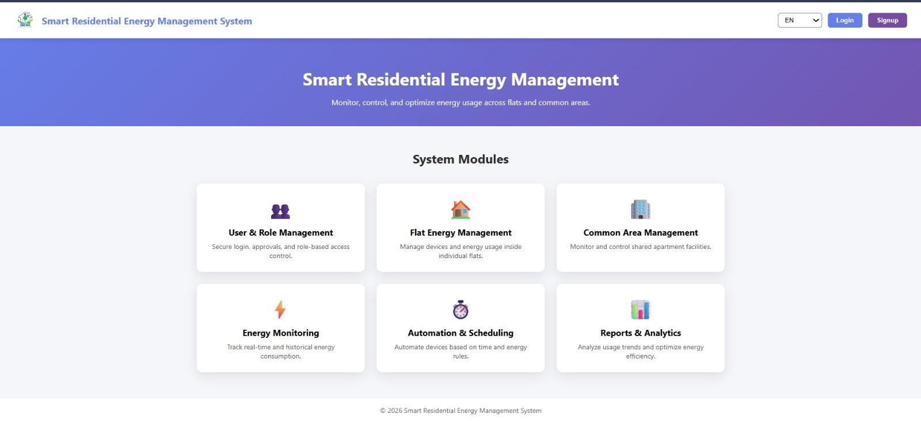

Admin Dashboard – Welcome Screen
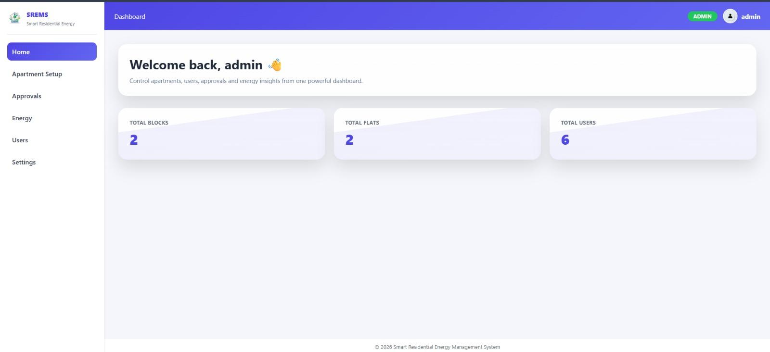

Energy Overview – Total Consumption Analytics
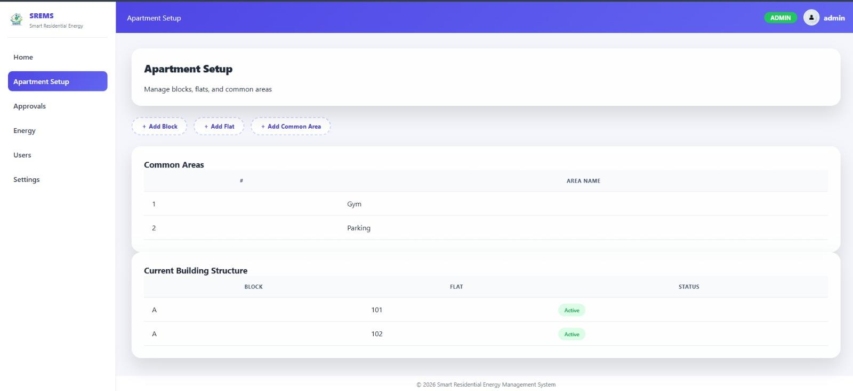

Apartment Setup – Blocks, Flats & Common Areas
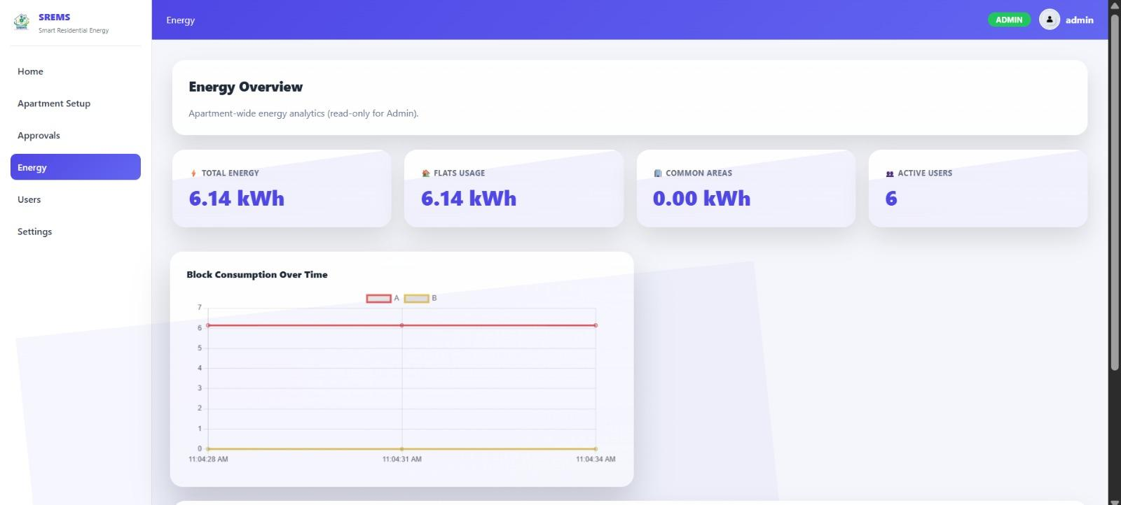

Flat Owner Energy Tracking Page
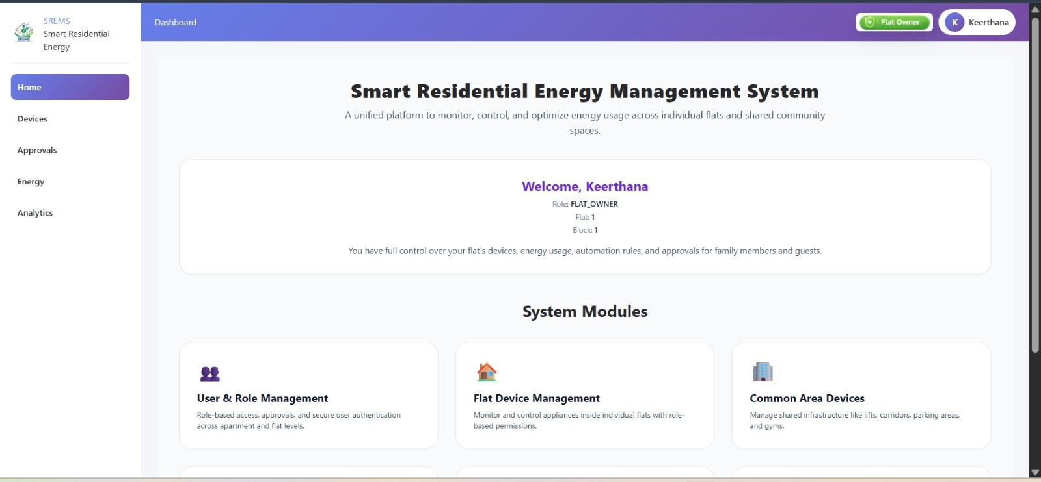

Flat Owner Device Management Screen
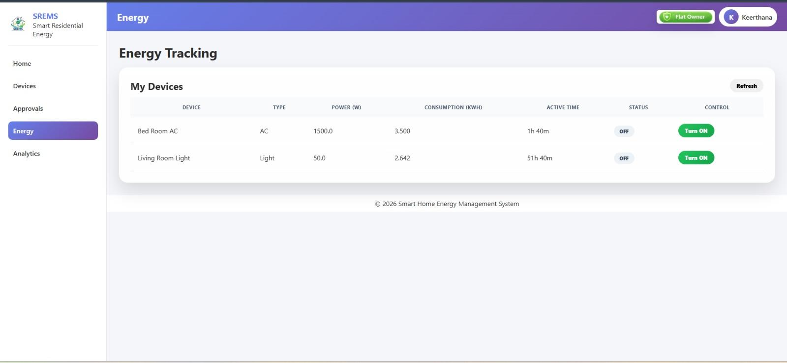

Flat Owner Dashboard – Role View
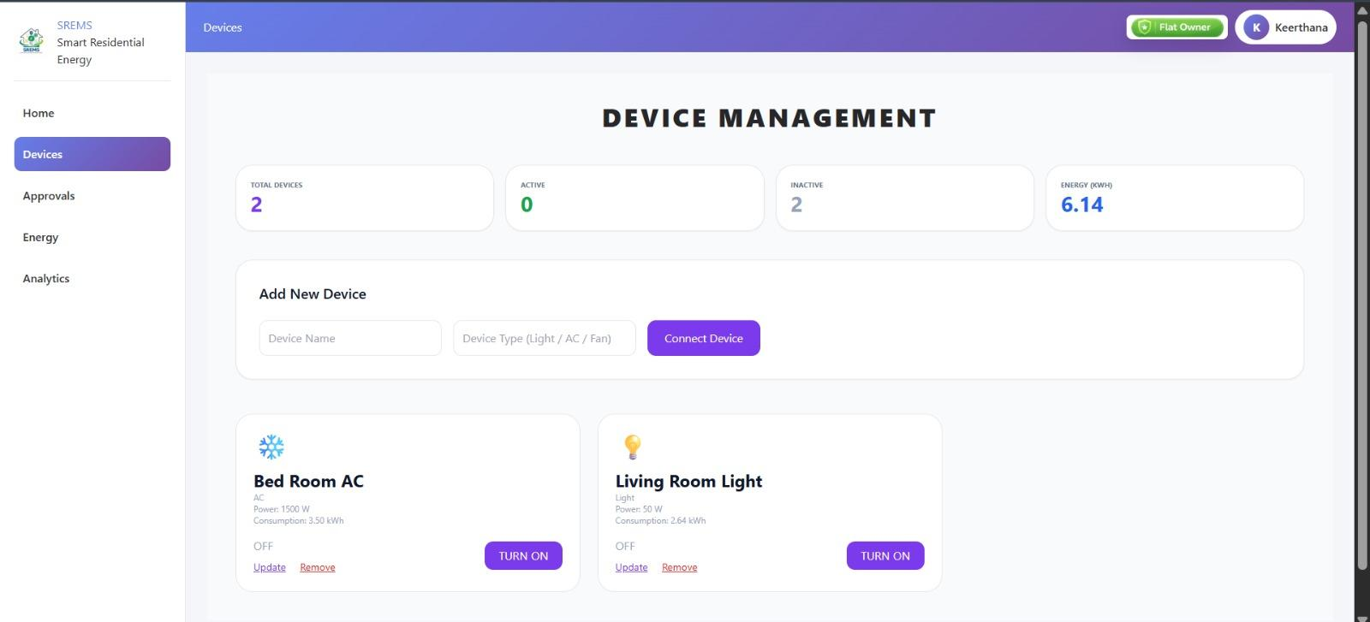

Login Page – Secure Authentication
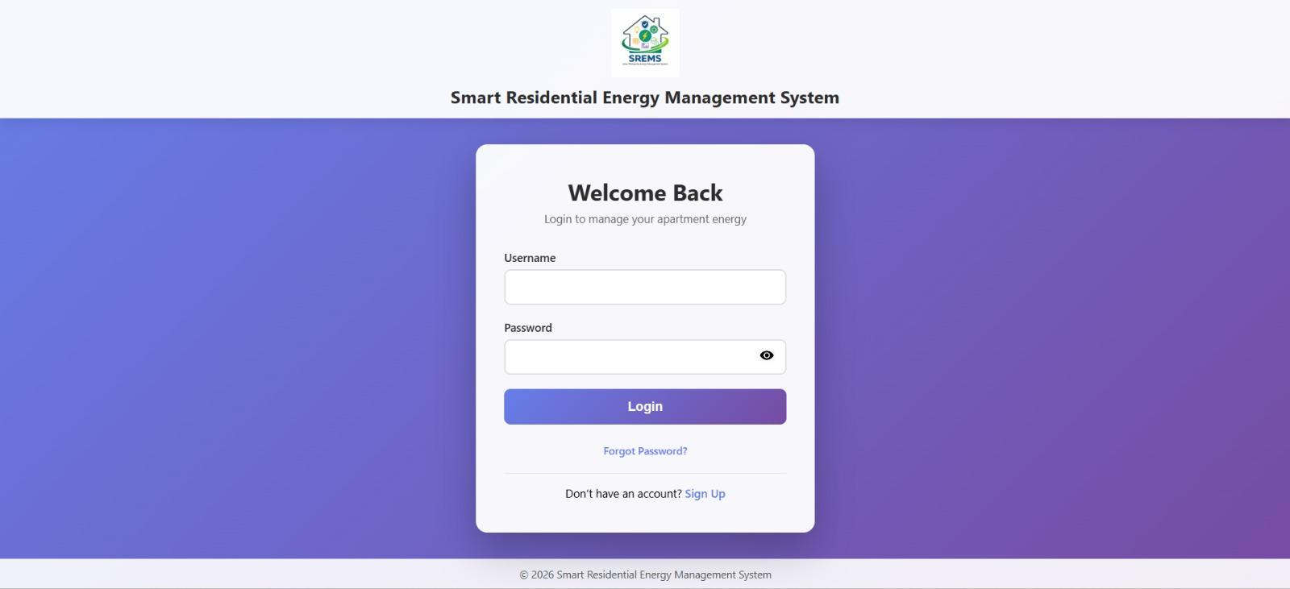

Signup Page – New User Registration
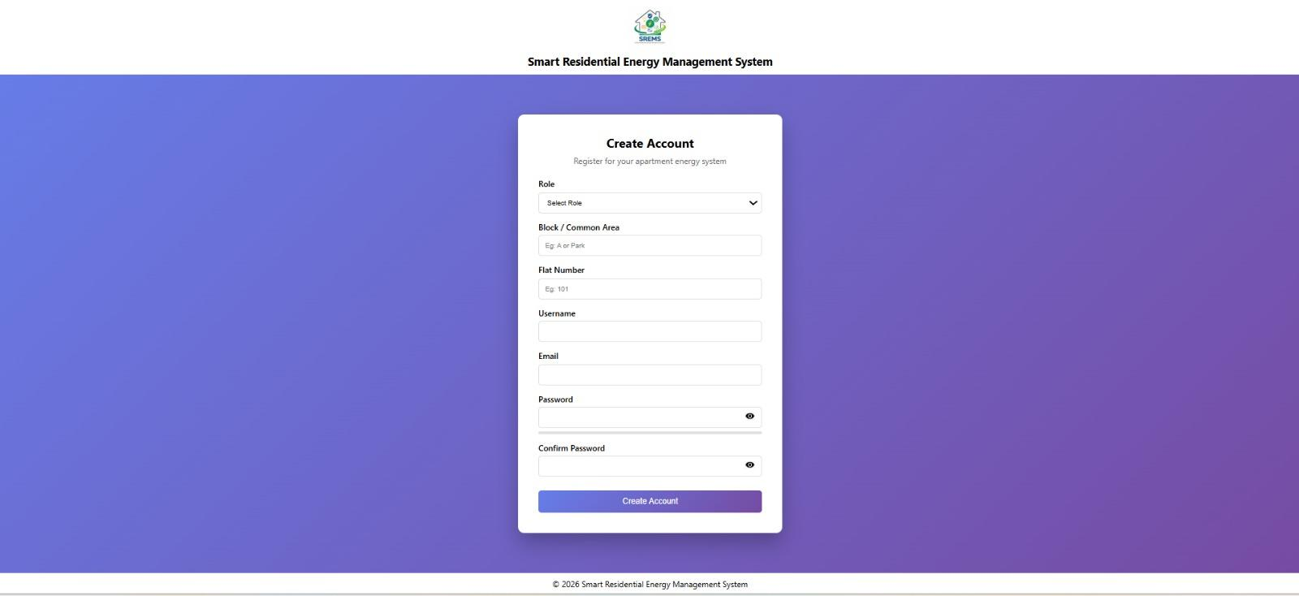
7) Challenges Faced
Challenge 1: Secure User Authentication
Problem: Multiple users accessing the system without proper identity separation can lead to unauthorized actions and security risks.
Solution: Implemented individual user accounts with login validation and role-based access control to ensure secure system entry.
Challenge 2: Role-Based Access Management
Problem: Different users (Admin, Family Member, Guest) require different permissions, but improper role handling can expose critical controls.
Solution: Defined strict role rules where each role is allowed to access only permitted features, preventing misuse of sensitive operations.
Challenge 3: Preventing Guest Misuse
Problem: Guests controlling critical devices such as ACs, heaters, or security systems can compromise safety and energy efficiency.
Solution: Restricted guest access to non-critical devices and enforced time-limited permissions.
Challenge 4: Consistent Smart Device Registration
Problem: Improper device registration can result in duplicate entries, invalid devices, or incorrect ownership mapping.
Solution: Implemented device validation rules and linked each device to a specific authenticated user.
Challenge 5: Device Control Conflicts
Problem: Multiple users attempting to control the same device can cause inconsistent device states.
Solution: Centralized device control logic in the service layer to maintain a single source of truth for device status.
Challenge 6: Authentication–Device Module Integration
Problem: Allowing device control without verifying user authentication can break system security.
Solution: Integrated Module 1 and Module 2 such that device operations are accessible only after successful login.

8) Conclusion
The Smart Residential Apartment Energy Management System (SREMS) project successfully achieved its primary objective of designing and implementing a secure, scalable, and modular energy management platform for residential apartment communities. Through a structured milestone-driven approach, the team developed key functionalities such as multi-role authentication, role-based access control, smart device management, real-time energy monitoring, alerts, analytics dashboards, and automation scheduling using Java Spring Boot and MySQL.
The project demonstrated how modern software engineering practices can be applied to address real-world challenges related to electricity monitoring and energy optimization in both individual flats and shared apartment facilities. By following a layered architecture and secure development principles, the system ensures maintainability, extensibility, and strong protection against unauthorized access.
This internship provided valuable exposure to full-stack development, system architecture design, database integration, module-based implementation, and collaborative teamwork. The experience strengthened technical expertise while also enhancing communication, coordination, and problem-solving skills. Overall, SREMS establishes a strong foundation for future enhancements such as IoT sensor integration, AI-based energy prediction, mobile application support, and advanced billing transparency, making it a meaningful and practical solution for sustainable smart residential living.

